Framework for Project Management
- Project Management as a Profession
- The Project Management Institute (PMI)
- Project Management Knowledge Areas
- Project Management Certifications
- Scrum development
- The Project Management Office

Project Management as a Profession
- Body of Knowledge
- Standards
- Professional organizations
- Currently, anyone can call him or herself a project manager
- Unresolved issue: to what extent can an expert PM move from one industry to another?

Project Management Standards
- Standards organizations
- PMI
  - Project Management Institute: http://www.pmi.org/
  - CAPM, PMP and other professional standards
- IPMA
  - International Project Management Association: http://ipma.ch/
  - Several certifications

Project Management Institute (PMI)
- Established in 1969
- Certifications: most popular is PMP
  - Also offer CAPM, for novice PMs, and several specialized certifications •
- Currently over 590,000 PMPs in the world
- Have published the Project Management Body of Knowledge or PMBOK, now in its 7th edition.

Project Management Professional (PMP)
- Requirements:
  - 5 years of project management experience
  - pass a rigorous exam
  - maintain ongoing professional development
- Currently over 590,000 PMPs in the world
- The CAPM or Certified Associate in Project Management only requires an exam and is considered to be a step along the way to a PMP

PMBOK Knowledge Areas
- Managing Integration
- Managing Scope
- Managing Time/Schedule
- Managing Costs
- Managing Quality
- Managing Human Resources
- Managing Communication
- Managing Risks
- Managing Procurement
- Managing Stakeholders

Project Integration
- Very active during the startup
- Coordinates all activities in all other knowledge areas

Project Scope
- Scope generally defines what the project is all about
- Forms the basis of the agreement between the project SPONSOR and the project team
- Changes in the scope may be proposed at any time during a project but should follow a clearly defined approval process

Scope Statement
- Description of the scope
- Acceptance criteria
- Deliverables
- Exclusions
- Constraints
- Assumptions

Work breakdown structure or WBS
WBS is the breakdown of the deliverables into manageable units of work.

Schedule and Time Management
- Based on the units of work defined by the WBS
- Resources required are identified
- Time durations are estimated
- Dependencies are identified (such as, what task must be completed before another task can begin)
- And a schedule can be created
- Several methods are available
- Software is frequently used to assist with managing the time schedule

Project Costs
- Develop a budget
  - Several methods can be used to estimate
- Plan for the cash flow
- Track the expenditures
- Explain deviations and make adjustments where required

Project Quality
Quality plan defines
- The quality standards
- The methods that will be used to achieve the standards
- The methods that will be used to measure the standards

Human Resources
- Identification of HR requirements
- Selection of project team
- Development of project team
- Motivation and management of the project team

Communication
- Communication includes within the team and with others outside the team
- The project should have a communication plan
  - Who needs to be communicated with
  - What methods will be used
  - What frequency
  - Who within the project will be responsible

Risk
- Risk represents the likelihood of the occurrence of an event that will negatively or positively impact the achievement of the project goals
- Processes:
  - Identify risks
  - Analyze risks
  - Manage risks

Procurement
- Contracting to obtain supplies or services required to carry out the project
- May be extremely complex
- Time schedules can be crucial
- Complex projects almost always involve additional experts such as lawyers

Stakeholder Management
- Stakeholders are people or organizations who either will be impacted by the project or who can impact the project.
- Always include: the project sponsor, the project team
- May include: customers, suppliers, vendors, the public, land owners, voters, other departments within the organization, government, etc
- The major tool is the stakeholder register
- Lists stakeholders, roles, and all communications
- Updated regularly throughout the project
- New stakeholders can appear at any time

PMI Process Groups
- Project Initiating
- Project Planning
- Project Executing
- Project Monitoring and Controlling
- Project Closing

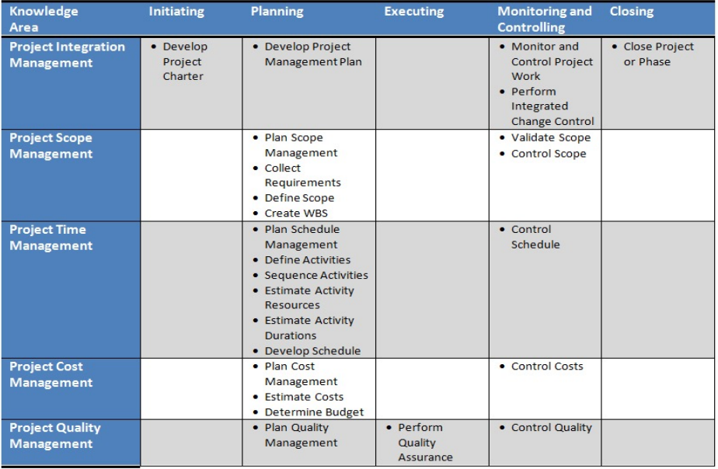
Knowledge Areas (PMBOK)

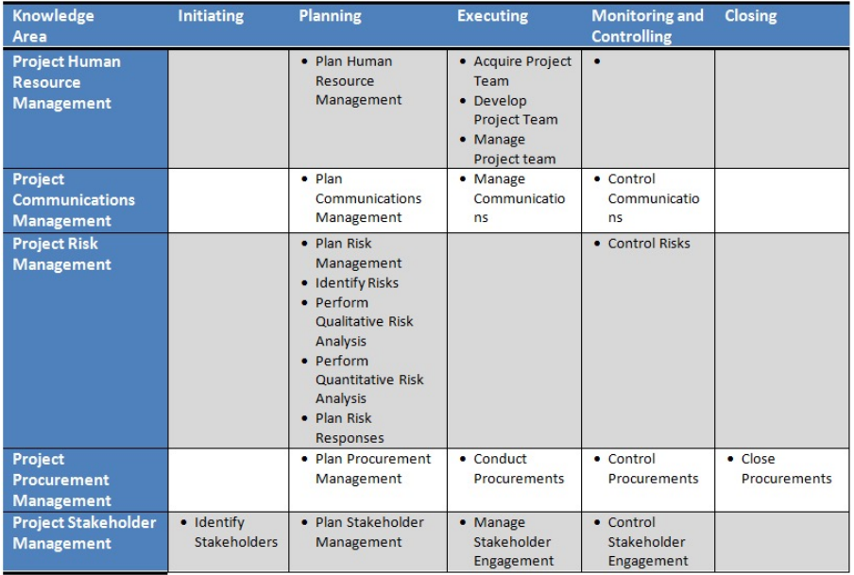

Scrum Development Overview
- Known as an Agile method
- Used when requirements are difficult to define or subject to rapid change
- Iterative approach
- Uses sprints or 2 to 4-week cycles
- Roles
  - Product owner
  - Scrum Master
  - Development Team
    - May include specialist roles such as developer, subject matter expert
- Priorities: stories are either on the:
  - Front burner (currently working on)
  - Back burner (next up)
  - Fridge (for later)
- Priorities are revisited before each new sprint
- Daily stand-up meeting (short meeting with fixed agenda)
  - What was done yesterday
  - What will be done today
  - Are there any problems the scrum master must address, such as resource issues out of the control of the team

Scrum Development Caveats
- Requires committed, mature developers
- Major work must still be done upfront
- Needs the commitment and involvement of the Product Owner
- Best for products that require frequent updates
- Not so good for large, totally new products that will not allow frequent updates after release

The Project Management Office (PMO)
- Medium and large organizations
- Typical objectives
  - Align projects with organizational objectives
  - Set standards for projects
  - Provide resources to project managers
  - Provide training and mentorship
  - Provide facilitation
  - Stay abreast of best practices in Project Management
  - Repository for project reports and lessons learned

Framework for Project Management
- Project management as a profession
- The Project Management Institute
- Project Management Certifications: PMP, CAPM
- PMBOK overview: ten knowledge areas; five process groups
- Scrum methodology
- The Project Management Office

